Zion National Park Expects Steady Growth of Visitors

After another record-breaking year for visitation in 2017, Zion National park ranks as the third busiest national park in the United States. It has been breaking its record every year since 2014. The total of 3,189,696 visitors to the park in 2014 is an increase of 19.6% from 2010 (2,665,972 visitors). The 2014 total is 17% higher than the 10-year average of 2,718,666 visitors for 2004–2013. (Stats Report Viewer) Zion National park can expect a steady visitor growth for the coming years.

Zion National Park is known for its beautiful canyons, amazing hikes, and archeological sites. The park was first protected in 1909 when President William Howard Taft designated Mukuntuweap National Monument by the 1906 Antiquities Act. It was not called Zion until the Congress redesignated the monument as Zion National Park in 1919. Despite the Great Depression, visitation has been growing since it opened.

With more affordable forms of transportation, more people within and outside of the United States can travel to the national park. The more convenient accessibility to the park has led to increased number of visitors. While the greater number of visitations has economically benefited the local residents, overcrowding has been creating problems to the park and neighboring communities. For example, people have to wait in long lines to access park facilities, increased requirement for police forces, and more damage to the natural and cultural resources. All these things can detract visitors from the wonderful experience of visiting this national park.

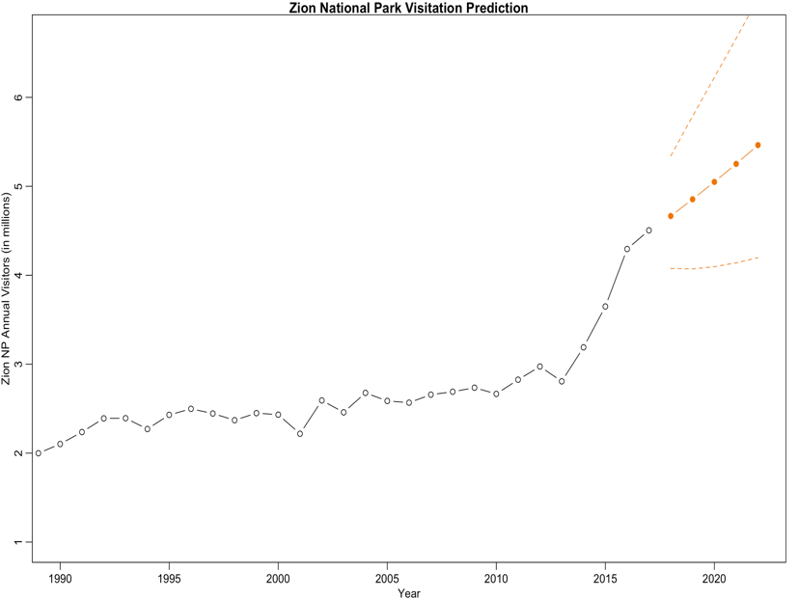Existing problems are not being treated seriously. Despite the growth of the visitation, Zion National Park has not received any substantial increase in funding. The most recent federal budget proposal designated an 8-percent decrease in park funding for 2018. (Fears). The prediction model indicates a 21 percent increase in visitors over the next five years.

There is no decline in visitations for the foreseeable future. Problems of overcrowding will only be exacerbated if funding does not increase. In order to mitigate these problems, people have proposed to double the park entry fees during the peak season, holidays and summer months. During holidays the park can be especially busy. Last Memorial Day, the park received over 30,000 visitors. (*National Parks Service*) Doubling the entry fee is not likely to solve these problems of overcrowding. While increase the entry will not reduce demand sufficiently, but will create more difficulties for low-income families to visit the public national park. Another approach to the problem is to restrict visitation by only taking reservations from visitors during peak seasons. This would provide a fairer chance for people to visit the park. However, the feasibility of this plan is questionable because of the large amount of expected visitation.

The beauty of Zion National Park keeps attracting people worldwide. This natural resource is revered by many throughout the world. Plans for cutting down on the number of tourists do not take into account hearts seeking beauty. Zion National Park needs to be prepared for the steady growth of visitors.

**Sources**:

“Stats Report Viewer.” *National Parks Service*, U.S. Department of the Interior, irma.nps.gov/Stats/SSRSReports/Park%20Specific%20Reports/Annual%20Park%20Recreation%20Visitation%20(1904%20-%20Last%20Calendar%20Year).

Fears, Darryl. “Interior Department Budget Could Be Slashed by 12 Percent.” *The Washington Post*, WP Company, 16 Mar. 2017, [www.washingtonpost.com/national/health-science/interior-department-budget-could-be-slashed-by-12-percent/2017/03/15/f0d7b2f8-0999-11e7-b77c-0047d15a24e0_story.html?utm_term=.b047223a7493](http://www.washingtonpost.com/national/health-science/interior-department-budget-could-be-slashed-by-12-percent/2017/03/15/f0d7b2f8-0999-11e7-b77c-0047d15a24e0_story.html?utm_term=.b047223a7493).

“Zion National Park Expecting Record Visitation Over Memorial Day Weekend.” *National Parks Service*, U.S. Department of the Interior, www.nps.gov/zion/learn/news/recordmday_5_22_18.htm.